《数据结构》实验报告（六）

学生姓名 李蔚
班 级 计算机2002
学 号 202801108
指导老师 陈 宏 建
成 绩

序号 | 项目名称 | 考核比重 | 得分
1 | 实验预习 | 10%
2 | 实验验收 | 60%
3 | 实验报告 | 30%

2021年 12月 15 日
实验名称： 图的应用
实验时间： 2021 年 12 月 8 日 第 13 周 星期 三
一、实验预习
1、实验目的
1）理解图的邻接矩阵创建方法，利用PRIM算法或克鲁斯卡尔算法实现求最小生成树。2）理解图的邻接表创建方法，实现拓扑排序算法

2、实验内容（包括自己设计增加的内容等）
利用PRIM算法或克鲁斯卡尔算法实现求最小生成树、实现拓扑排序算法
二、实验报告
1、实验结果（包括程序运行结果、实测数据结果、数据分析等）
//最小生成树
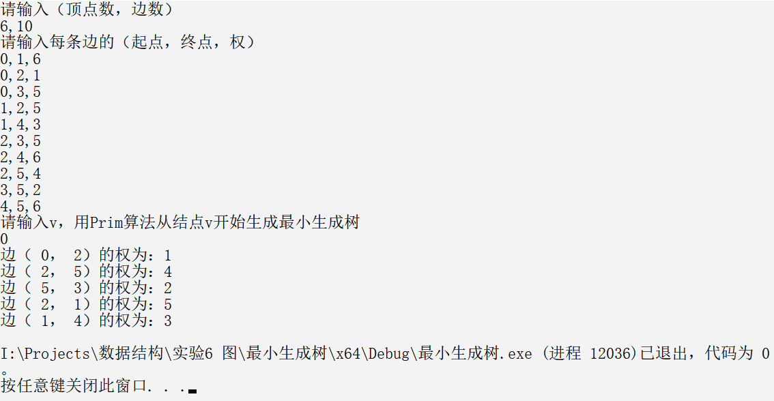
//拓扑排序
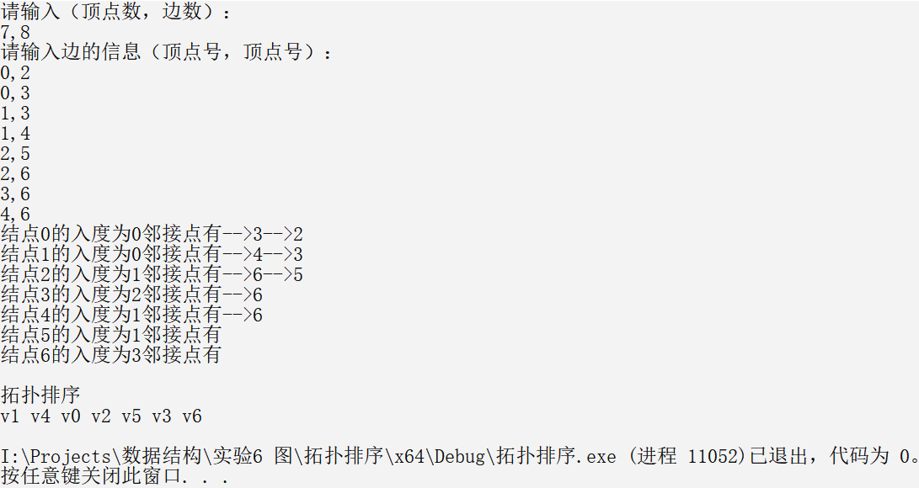
//图的遍历
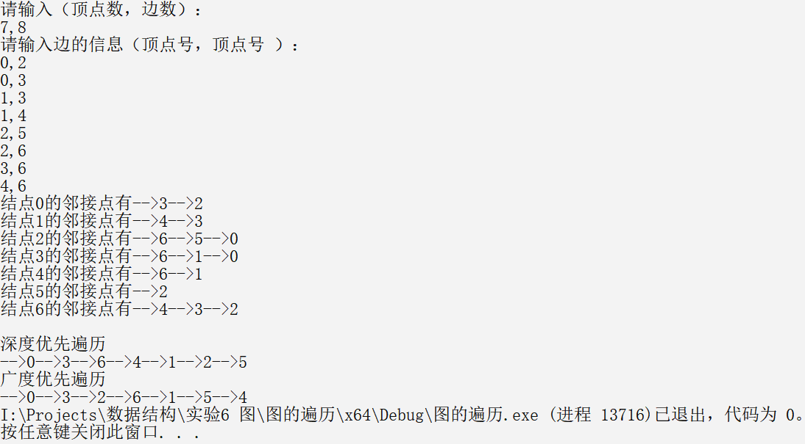
2、实验结论
验证了并用程序实现了以下算法：
用prim算法求最小生成树；拓扑排序；图的深度优先和广度优先遍历。
附录：（程序源代码）
//prim算法

#define _CRT_SECURE_NO_WARNINGS
#include<stdio.h>
#include<stdlib.h>
int n, e;//图的结点数和边数
int** CreateGraph() {
int** Graph;
Graph = (int**)malloc(sizeof(int*)*n);
for (int i = 0; i < n; i++)
*(Graph + i) = (int*)malloc(sizeof(int) * n);
for (int i = 0; i < n; i++)
for (int j = 0; j < n; j++)
Graph[i][j] = INT_MAX;
printf("请输入每条边的（起点，终点，权）\n");
int i, j, k;
for (int cnt = 0; cnt < e; cnt++) {
scanf("%d,%d,%d", &i, &j, &k);
Graph[i][j] = Graph[j][i] = k;
}
return Graph;
}
void Prim(int** Graph, int v) {//用Prim算法从结点v开始生成最小生成树
int* lowcost, * closest;
lowcost = (int*)malloc(sizeof(int) * n);
closest = (int*)malloc(sizeof(int) * n);
int min, i, j, k;
for (i = 0; i < n; i++) {
lowcost[i] = Graph[v][i];
closest[i] = v;
}
lowcost[v] = 0;
for (i = 1; i < n; i++) {
min = INT_MAX;
for (j = 0; j < n; j++)
if (lowcost[j] && lowcost[j] < min) {
min = lowcost[j];
k = j;
}
printf("边（% d，% d）的权为：%d\n", closest[k], k, min);
lowcost[k] = 0;
for (j = 0; j < n; j++)
if (Graph[k][j] < lowcost[j]) {
lowcost[j] = Graph[k][j];
closest[j] = k;
}
}
}
int main() {
printf("请输入（顶点数，边数）\n");
scanf("%d,%d", &n, &e);
int** Graph = CreateGraph();
printf("请输入v，用Prim算法从结点v开始生成最小生成树\n");
int v;
scanf("%d", &v);
Prim(Graph, v);
for (int i = 0; i < n; i++)
free(Graph[i]);
free(Graph);
return 0;
}
//拓扑排序
#define _CRT_SECURE_NO_WARNINGS
#include<stdio.h>
#include<stdlib.h>
#define MAX_VERMUM 20
typedef struct ArcNode {
int adjvex;
struct ArcNode* next;
}ArcNode;
typedef struct VNode {
int vertex;
int indegree;
ArcNode* firstarc;
}VNode;
typedef struct {
VNode AdjList[MAX_VERMUM];
int vexnum, arcnum;
}Graph;
Graph* CreateGraph() {
Graph* G;
G = (Graph*)malloc(sizeof(Graph));
printf("请输入（顶点数，边数）：\n");
scanf("%d,%d", &G->vexnum, &G->arcnum);
for (int cnt = 0; cnt < G->vexnum; cnt++) {
G->AdjList[cnt].vertex = cnt;
G->AdjList[cnt].firstarc = NULL;
G->AdjList[cnt].indegree = 0;
}
printf("请输入边的信息（顶点号，顶点号）：\n");
for (int cnt = 0; cnt < G->arcnum; cnt++) {
int i, j;
scanf("%d,%d", &i, &j);
ArcNode* s;
s = (ArcNode*)malloc(sizeof(ArcNode));
s->adjvex = j;
s->next = G->AdjList[i].firstarc;
G->AdjList[i].firstarc = s;
G->AdjList[j].indegree++;
}
return G;
}
void PrintGraph(Graph* G) {
for (int cnt = 0; cnt < G->vexnum; cnt++) {
printf("结点%d的入度为%d邻接点有",G->AdjList[cnt].vertex, G->AdjList[cnt].indegree);
ArcNode* p = G->AdjList[cnt].firstarc;
while (p != NULL) {
printf("-->%d", p->adjvex);
p = p->next;
}
printf("\n");
}
}
void TopSort(Graph* G) {
int i, j, cnt = 0, top = -1, * stack;
stack = (int*)malloc(G->vexnum * sizeof(int));
ArcNode* p;
for (i = 0; i < G->vexnum; i++)
if (G->AdjList[i].indegree == 0)
stack[++top] = i;
while (top != -1) {
i = stack[top--];
printf("v%d ", G->AdjList[i].vertex);
cnt++;
for (p = G->AdjList[i].firstarc; p != NULL; p = p->next) {
j = p->adjvex;
G->AdjList[j].indegree--;
if (G->AdjList[j].indegree == 0)
stack[++top] = j;
}
}
if (cnt != G->vexnum)
printf("网中存在环");
printf("\n");
free(stack);
}
int main() {
Graph* G = CreateGraph();
PrintGraph(G);
printf("\n拓扑排序\n");
TopSort(G);
return 0;
}

//图的遍历
#define _CRT_SECURE_NO_WARNINGS
#include<stdio.h>
#include<stdlib.h>
#define MAX_VERMUM 20
typedef struct ArcNode {
int adjvex;
struct ArcNode* next;
}ArcNode;
typedef struct VNode {
int vertex;
ArcNode* firstarc;
}VNode;
typedef struct {
VNode AdjList[MAX_VERMUM];
int vexnum, arcnum;
}Graph;
Graph* CreateGraph() {
Graph* G;
G = (Graph*)malloc(sizeof(Graph));
printf("请输入（顶点数，边数）：\n");
scanf("%d,%d", &G->vexnum, &G->arcnum);
for (int i = 0; i < G->vexnum; i++) {
G->AdjList[i].vertex = i;
G->AdjList[i].firstarc = NULL;
}
printf("请输入边的信息（顶点号，顶点号 ）：\n");
for (int cnt = 0; cnt < G->arcnum; cnt++) {
int i, j;
scanf("%d,%d", &i, &j);
ArcNode* s;
s = (ArcNode*)malloc(sizeof(ArcNode));
s->adjvex = j;
s->next = G->AdjList[i].firstarc;
G->AdjList[i].firstarc = s;
s = (ArcNode*)malloc(sizeof(ArcNode));
s->adjvex = i;
s->next = G->AdjList[j].firstarc;
G->AdjList[j].firstarc = s;
}
return G;
}
void PrintGraph(Graph* G) {
for (int cnt = 0; cnt < G->vexnum; cnt++) {
printf("结点%d的邻接点有", G->AdjList[cnt].vertex);
ArcNode* p = G->AdjList[cnt].firstarc;
while (p != NULL) {
printf("-->%d", p->adjvex);
p = p->next;
}
printf("\n");
}
}
void DFS(Graph* G, int v, int* visited) {
printf("-->%d", G->AdjList[v].vertex);
visited[v] = 1;
ArcNode* p;
for (p = G->AdjList[v].firstarc; p != NULL; p = p->next)
if (visited[p->adjvex] == 0)DFS(G, p->adjvex, visited);
}
void DFS1(Graph* G, int* visited) {
for (int cnt = 0; cnt < G->vexnum; cnt++)
visited[cnt] = 0;
for (int cnt = 0; cnt < G->vexnum; cnt++)
if (visited[cnt] == 0)DFS(G, cnt, visited);
}
void BFS(Graph* G, int v, int* visited) {
printf("-->%d", G->AdjList[v].vertex);
visited[v] = 1;
ArcNode* p = G->AdjList[v].firstarc;
int* queue, q, front = 0, rear = 0;
queue = (int*)malloc(G->vexnum * sizeof(int));
rear = (rear + 1) % G->vexnum;
queue[rear] = v;
while (front != rear) {
front = (front + 1) % G->vexnum;
q = queue[front];
for (p = G->AdjList[q].firstarc; p != NULL; p = p->next)
if (visited[p->adjvex] == 0) {
printf("-->%d", G->AdjList[p->adjvex].vertex);
visited[p->adjvex] = 1;
rear = (rear + 1) % G->vexnum;
queue[rear] = p->adjvex;
}
}
free(queue);
}
void BFS1(Graph* G, int* visited) {
for (int cnt = 0; cnt < G->vexnum; cnt++)
visited[cnt] = 0;
for (int cnt = 0; cnt < G->vexnum; cnt++)
if (visited[cnt] == 0)BFS(G, cnt, visited);
}
int main() {
Graph* G = CreateGraph();
PrintGraph(G);
int* visited;
visited = (int*)malloc(G->vexnum * sizeof(int));
printf("\n深度优先遍历\n");
DFS1(G, visited);
printf("\n广度优先遍历\n");
BFS1(G, visited);
return 0;
}

